Name-Ujjawal Mandhani
Batch-F6
Enroll No.-9918103237
ISL Lab-Week 2 D

Question 2:
Filtering out ip_addr==my_ip_addr
ip.addr==192.168.43.XX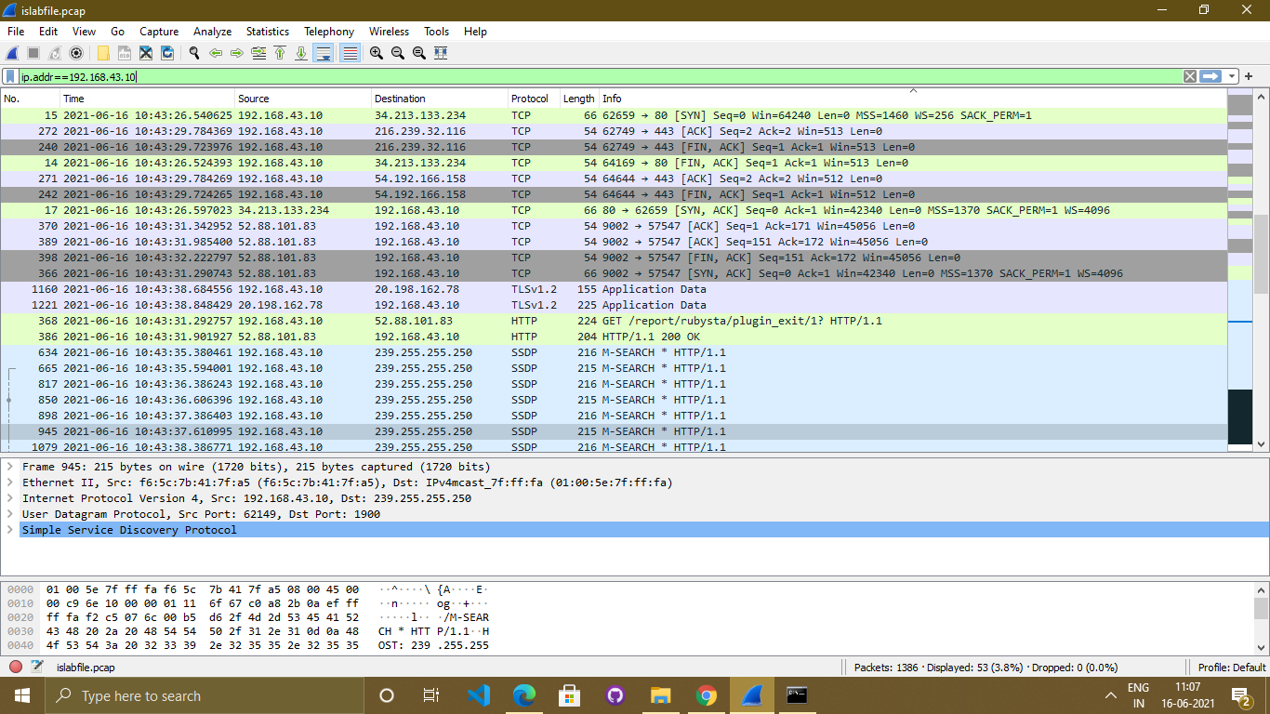

Question 3:
DNS queries are sent over UDP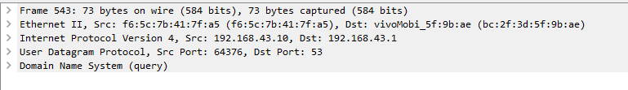
Question 4:

Src Port: 64376, Dst Port: 53

Question 5:

HTTP uses TCP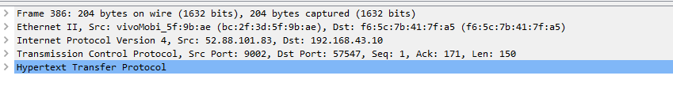
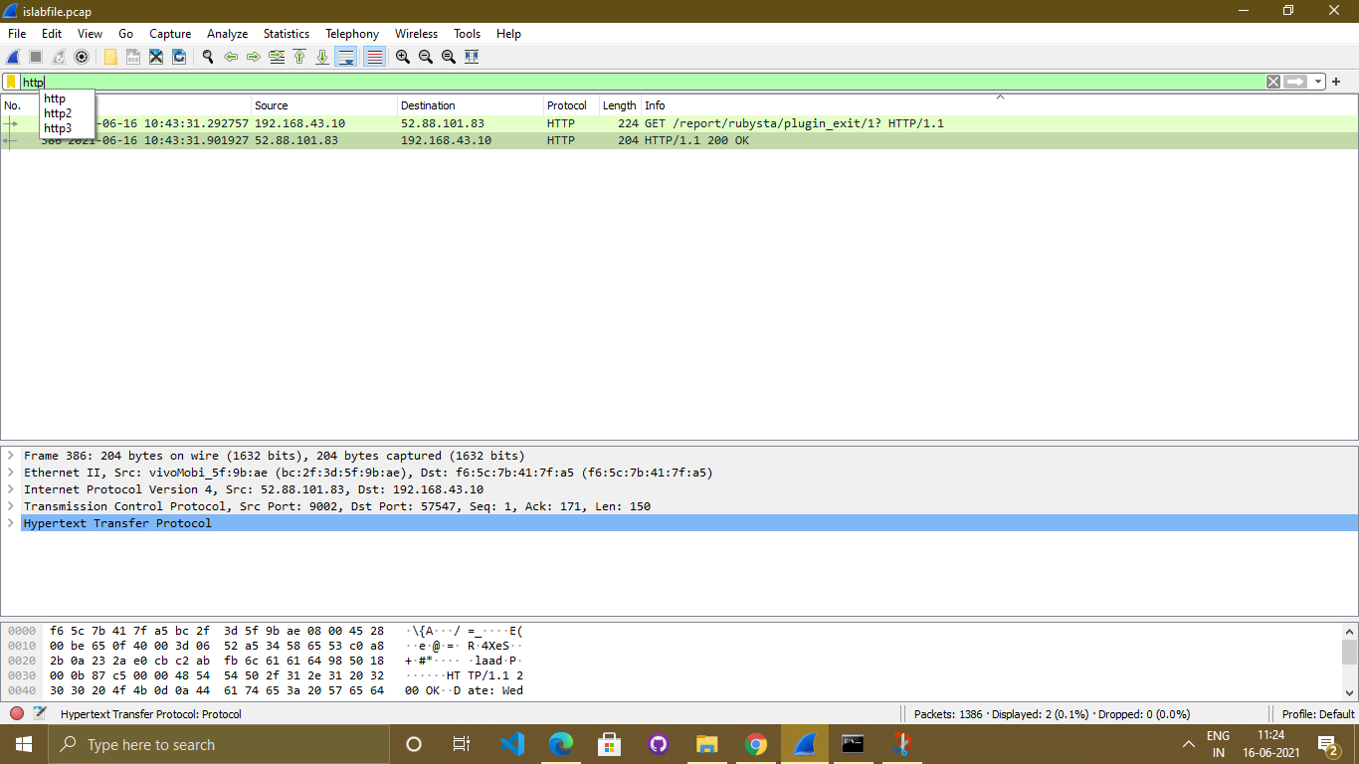
Question 6:

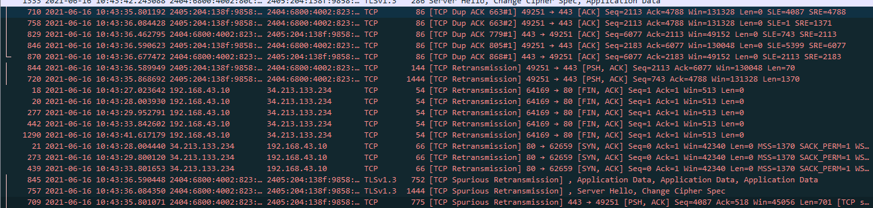

Question 7:

(a) 3 common IP address: 131.247.92.200, 131.247.95.216, 64.233.161.99
Name: www.google.com

(b) In packets 3,4 and 5 TCP 3-way handshaking is taking place
Packet 3-> SYN, Packet 4-> SYN, ACK and Packet 5->ACK

(c) HTTP GET request is sent in frame 6 and is acknowledged in packet 7

(d)Packet 10 has HTTP get query response

(h) In packet 23, a GET request was sent to fetch an image icon, and packet 25 contains a response for get request

(i)Accessing a webpage and its components(images etc)

